**Electrical Circuits Practice**

1. In the circuit below, what is the value of *R* if the reading on the ammeter is 0.04 A? **150 Ω**

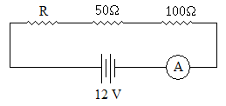

1. Find the value of *R* in the circuit below if the reading on the ammeter is 0.8 A. **60 Ω**

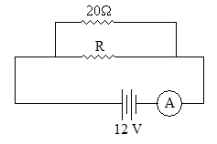

1. Find the readings on the voltmeter and ammeter in the circuit below. **V = 2.4 V, I = 0.096 A (96 mA)**

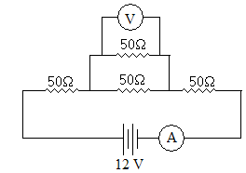

1. Find the reading on the ammeter in the circuit below. **0.48 A (480 mA)**

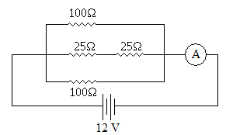

1. Find the readings on the voltmeter and ammeter in the circuit below. **V = 6 V, I = 0.2 A**

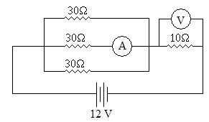

1. If the switch in the circuit below is opened, how will the brightness of the light be affected (if at all)? Explain why. (Hint: brightness is proportional to power.) **The light’s brightness will decrease. The globe’s power output is approximately 0.4 W with the switched closed but only 0.3 W with the switch open.**

|  |  |
| --- | --- |
| With switch closed: $$R_{\text{T}}=20+40+\frac{1}{\frac{1}{60}+\frac{1}{60}}+100$$ $$R_{\text{T}}=190 Ω$$ $$I_{\text{T}}=\frac{V_{\text{T}}}{R_{\text{T}}}=\frac{12}{190}=0.063158 \text{A}$$ $$I_{\text{globe}}=I_{\text{T}}$$ $$V_{\text{globe}}=I_{\text{globe}}R_{\text{globe}}=6.3158 \text{V}$$ $$P_{\text{globe}}=V_{\text{globe}}I_{\text{globe}}=0.399 \text{W}$$ | With switch open: |

1. Find the readings on the voltmeter and ammeter in the circuit below. **V = 9.6 V, I = 0.48 A**

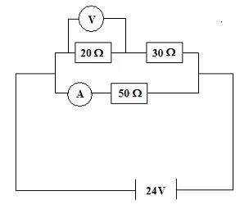

1. Three resistors with resistances of 20 Ω, 30 Ω, and 50 Ω are connected in series with a 12 V power supply. Calculate:
   1. the total resistance **100 Ω**
   2. the current flowing in each resistor **0.12 A**
   3. the potential difference across the 30 Ω resistor **3.6 V**

The resistors are then connected in parallel. Find:

* 1. the total resistance **9.68 Ω**
  2. the current through the 30 Ω resistor **0.4 A**

1. An electrical engineer has set up the following circuit in an electrical device. Find the total resistance of the circuit and the readings on both meters. **R = 443 Ω, V = 23.2 V, I = 0.0774 A (77.4 mA)**

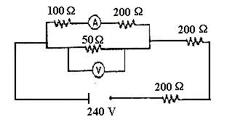

1. The following set of resistors is connected as shown:

* 1. What is the effective resistance between points A and B? **13.5 Ω**
  2. If a potential difference of 24 volts was applied from A to B, what total current would flow through the circuit? **1.78 A**
  3. What would the current through the 9 Ω resistor be while the 24-volt potential difference was being applied? **0.667 A**
  4. Explain (without calculations) how you would rearrange the resistors above to create:
     1. the circuit with the maximum possible resistance **Place all the resistors in series**
     2. the circuit with the minimum possible resistance **Place all the resistors in parallel**

**Challenge Questions**

1. Work out the values reported by each ammeter and voltmeter in the circuit below.

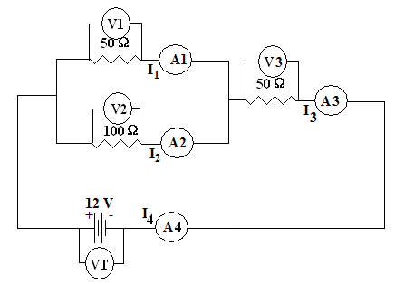**VT = 12 V**

**I3 = I4 = 0.144 A**

**V3 = 7.2 V**

**V1 = V2 = 4.8 V**

**I1 = 0.096 A**

**I2 = 0.048 A**

1. Work out the values reported by each ammeter and voltmeter in the circuit below.

**V1 = 12 V**

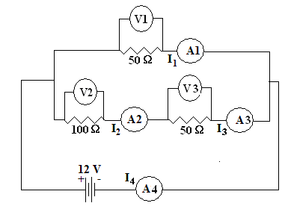**I4 = 0.32 A**

**I1 = 0.24 A**

**I2 = I3 = 0.08 A**

**V2 = 8 V**

**V3 = 4 V**

1. Work out the values reported by each ammeter and voltmeter in the circuit below.

**I1 = 0.820 A**

**V1 = 164 V**

**I2 = 0.745 A**

**V2 = 38.8 V**

**I3 = 0.776 A**

**V3 = 17.3 V**